Name: ____________________ Date:____________ /25

**Year 7 Chemistry Vocabulary Test**

**You will need to use the following words to label the diagrams, some words may be used twice and others may not be used at all**

*filtrate, chromatography, sediment, magnetic, residue, solution, condensation, distillation, evaporation, decanting, solution, distillate, filtration, suspension, centrifuging*

What is the process below called? _____________________________

[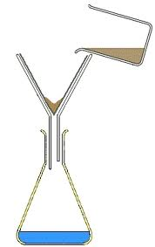](http://www.google.com.au/imgres?q=filtration&hl=en&safe=strict&gbv=2&tbm=isch&tbnid=YGJxz--3jTRyLM:&imgrefurl=http://www.sciencequiz.net/jcscience/jcchemistry/practicals/filtration.htm&docid=g-N_f8feAwE5QM&imgurl=http://www.sciencequiz.net/jcscience/jcchemistry/practicals/images/filtration.jpg&w=247&h=393&ei=y8vCT7jZFMiYiAeR_v3ECg&zoom=1&iact=hc&vpx=605&vpy=103&dur=1297&hovh=283&hovw=178&tx=89&ty=162&sig=109588356345036989880&page=1&tbnh=134&tbnw=84&start=0&ndsp=53&ved=1t:429,r:3,s:0,i:77&biw=1920&bih=931)

What separation process could produce the results below?

_________________________________

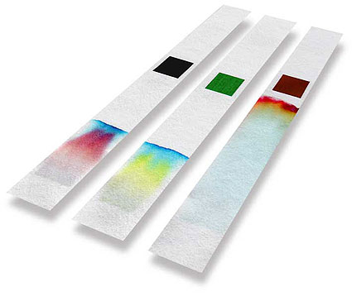What separation technique is being demonstrated below? _________________________

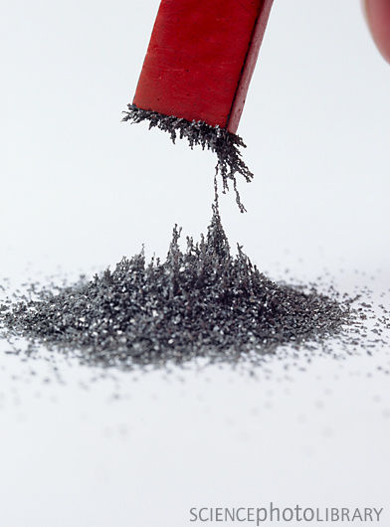

[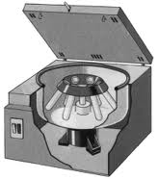](http://www.google.com.au/imgres?hl=en&biw=1920&bih=931&gbv=2&tbm=isch&tbnid=Mt00rUM3KAFsRM:&imgrefurl=http://daphnedesign.wordpress.com/page/5/&docid=WGJqS98jMTXdPM&imgurl=http://daphnedesign.files.wordpress.com/2011/10/centrifuge.gif?w=545&w=205&h=233&ei=NRXDT7aTAeuaiAf9hsygCg&zoom=1&iact=hc&vpx=188&vpy=151&dur=11850&hovh=186&hovw=164&tx=98&ty=130&sig=109588356345036989880&page=1&tbnh=133&tbnw=117&start=0&ndsp=52&ved=1t:429,r:0,s:0,i:71)

The machine to the left spins the test tubes very fast. What separation technique is this machine designed for? __________________________

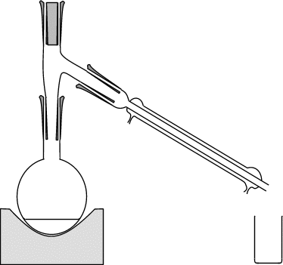 What process is occurring here?

Which separation process is the equipment to the right used for?

_________________________

What process is occurring here?

What is the process below called? _______________________________

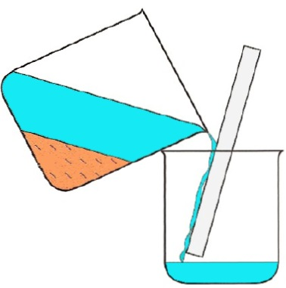What type of mixture is this technique useful for? ________________________

*Write the number of the correct definition in the box next to each term.*

Concentrated 1. A substance that is able to dissolve in another substance.

Solvent 2. A mixture made of particles smaller than that in a suspension, but larger than those in a solution.

Colloid 3. The substance in which a solute dissolves.

Insoluble 4. A mixture of a liquid in a liquid. The liquids don’t dissolve in each other

Saturated 5. A lot of solute dissolved in a little solvent.

Soluble 6. A substance that cannot dissolve.

Solute 7. Light can pass through, you can see through it.

Colourless 8. A substance made from two or more pure substances.

Emulsion 9. The substance that is being dissolved.

Dilute 10. Little solute dissolved in a lot of solvent.

Mixture 11. What a solution is called when the solute will no longer dissolve in it.

Clear 12. Has no colour.